**Examining switching of different dimensions in Universe and ways and phenomena that can be involve in Time Travel.**

Written by: Mohammad Tanzil Idrisi

We commonly understand dimensions are a thing of science fiction. However, we mostly know that we live in a 3D world. And when we have asked that what the fourth dimension, could be, we’re usually met, with the answer of, “It is time”. However, how many of us know what such things mean? Let’s make it more simple by taking an example that we as humans, understand four different dimensions. We believe a dot, which is Zero dimension. That dot can go to become a line, which is 1D(one Dimension). That line could become a plane or a square, which is 2D. And that’s where an object can eventually become a 3D thing, a 3D object. So, you go back and forth between these sorts of dimensions.

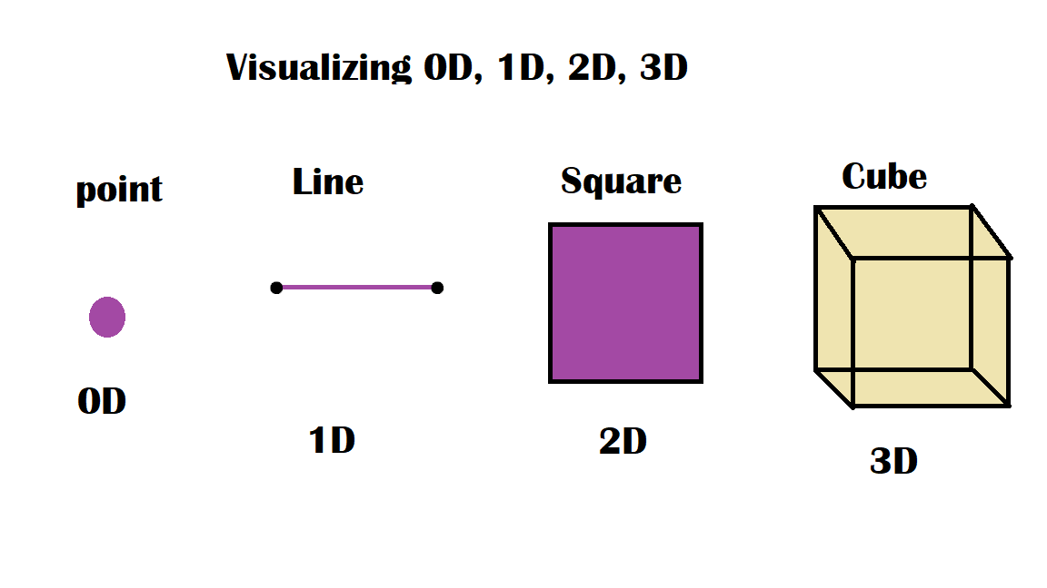

In calculus, a very important tool exists. And that tool is called integration. Believe it or not, integration allows us to travel between dimensions. For example: if we were to integrate a line on a graph, we would get the 2D area under it. Here, we’ve gone from 1D, which is a line, to the 2D areas under it. And if we were to integrate a 2D area on a 2D graph, we would usually get the 3D volume under it. So, following the same pattern, if we were to integrate a 3D object, we would get a fourth-dimensional body.

However, let’s make it more simple, and imagine there is a dot on board. A dot, as agreed before, is in zero dimension. If we have a lot of dots next to each other like so in the same direction, we’d eventually end up with a line. Here, we’ve gone from 0D, all the way to 1D. Now, if we take that line and push it up a bit, that line which is 1D, if we try to add in lot more lines under each other, we’d eventually get a plane. And that is how we move from 1D to 2D. Now, if we were to go further- a square on SolidWorks — we can expand this into 3D. Just like a book, a lot of pages that represent 2D planes, stacked up against each other.

Now let’s try visualizing the fourth dimension, using the same method. If we just had a lot of 3D volumes next to each other, we just get bigger volume? For that glitch in the system, we’re going backtrack to the logic to sort of visualizing what 4D could be like. If we bring in a 3D object, like a cuboid, we would discover that the 3D object is made up out of a lot of different 2D planes, just like a book. If we were to take one of them out, we’ve gone from 3D to 2D. Let’s for the intention of this presentation call this an element. If we were to take that plane and dissect it just the same way, we get out of the 2D object, one element out of that 2D object would be a 1D object, a line. And if we were to go down a step further, and disintegrate that line, we would get a single element of that line, which is the zero dimension.

Now, if we put all of this together, the fourth dimension is just a big collection of threedimensional objects. But the trick over here isn’t to add them up physically. It’s to add them up in a way that makes sense. Just like a movie, where we’ve got a lot of different frames that are played at a quick speed, you would see the flow of these frames. You would see the movie. Just like I were to move the arm, every single 3D snapshot of me moving my arm put together would create the flow of this 3D object, and you would eventually get movement. So essentially, we could gather the entire time-frame from the beginning of his life till his death. Maybe even further. And put them into one specific reel. And for all intents and purposes, we’ll call this, for now, the visualization of the fourth dimension. If we were to use this information to extrapolate different and further different dimensions, we could go further to 5D. But before going to 5D, let’s go back to a bit of calculus.

If we were to integrate a 3D object, what do we get? We’d usually get a mass flow rate, a volumetric flow rate, anything that has some sort of connection to time, which further provides the evidence we need to call this thing time. And as we move along this flow of the 3D snapshots we have, we’d eventually have to put these marking down, which is what we call time, which is what we call one o’clock, two o’clock, three o’clock, and so on. If we were to expand into 5D, we would have to have a lot of elements out of the fourth dimension, simply put them into the fifth dimension. And over here, we’d have four different time reels, if you will. The first time reel; four is just a representative figure. Although, it has no physical meaning. The first reel could be the universe as we know it right now. The timeline from the beginning till the end is packed into a one-time reel. However, others would be a little changed. What that means is every single element out of the fifth dimension, which is a four-dimensional thing, would have different actions, would have different, things happen in it. And if we bunch all of these things together and put them into a box-like so, we can safely call this the fifth dimension. I think this might look like a parallel universe theorem. We are going to look at the person at this 5D state, we would be able to look at that person in all different choices whether to do mechanical, electrical engineering, and so on.

Let’s take this a step further, by grabbing a bunch of these boxes, which are 5D, and together, they theoretically, if they ever will, would create 6D. Just like time reels where something changed between the one-time reel and another, something would change over here, and that would be our morphological structure if you will. So for example, in the first box, we would be just like we are right now. That’s where we are, in that first tiny box. If you were to go to the second box, I might have two arms instead of one, or two minds instead of one. No one knows. We can only theorize about this. However, if you were to look at a person in 6D, so elements of 5D all group together, you would be able to see all the different choices this person can ever make, all grouped with how he could physically look like. Now, if we were to expand this and take this to 7D, let’s say. And here is where normal things get more complicated than it seems. For a second just stop imagining about the box. In 7D, what would change on the plane, if 7D would be the physical laws that govern our universe (atomic structure)? For example, in one element of 7D, gravity could work a little differently.

In another element of 7D, you could have the atomic structure change a little, from electrons and photons and neutrons. To get to the final level imaginable with this specific theory or way of thinking, which is 8D, 8D would represent the concept of existence. In one element of 8D, which is where we are, we would understand this specific concept of existence, but in other elements, it might be a little different. And it’s important to know that even though we think we live in only the third dimension if the fourth dimension were to exist if the eight dimensions were to exit, we were only one tiny speck in all of these dimensions put together. We’re not just in the third dimension. Let’s go to the basic definition of dimension if you will. If I exist in 1D, that means I can move in only one direction, as explained previously. I’d be able to move left and right.

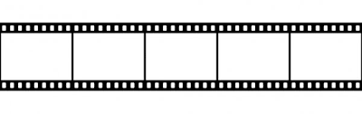

I exist in 2D, just like a plane or a picture, let’s say, I’d be able to move left and right, up and down. And because we live in the third dimension, we can move in three different directions. We can move left and right, up and down, forward and backward. And this means that, if we were to extrapolate this into the fourth dimension, we would need this extra way to walk through, this extra freedom. To explain, if I go back to the tape analogy — just like a movie where you have it on your iPhone, let’s say — you can scroll back and forth between the frames on that video. And that would be the same thing. If we visualize a video made out of 3D snapshots of basically our lives, we would be able to walk through the frames. I walk forward, I would be able to travel into the future. And if I were to walk backward, I would go to the past. And if I were to stand still where I am I would be able to freeze time to myself. But here’s the thing: if we walk across this time-frame, we need to know how to get access to this lane of time, to eventually time-travel. To explain this: I need my childhood friend of mine, The stickman figure.

Let’s say we take a stickman figure and we draw him on a piece of paper. Remember, that a stickman figure is a 2D object, and paper is a 2D object. And lets for intents of this reel say this stickman figure wants to exit his 2D world and come into our 3D world. To do that, we’d have to tell that stickman figure to push out of the paper to get free out of the boring 2D world he lives in and get out into the 3D world. However, that stickman figure has lived his entire life going left, right, up, and down. He doesn’t know what push out of the paper means. And let’s say he does push out of the paper. We wouldn’t b able to see him. Because he wouldn’t have any depth in our 3D world. He would be undefined. Just like my friend Nadeem, little guy, we are 3D human beings that are attempting to break into the 4D world to time-travel, and we have lived our entire lives learning how to go left, right, up, and down, straight, and backward. Where can we find this place where we can push through to break out of our current frame on time — frame and walk through time-frames and travel through time, have the freedom to walk through time? Imagine, how we can do this?

Let’s go deep because as I’ve said before, we only learned to go in three different directions. And even if we were able to break out of the time of that specific frame and get out into that lane of time, to break out that specific frame and get out into that lane of time, we wouldn’t have any depth in the fourth dimension. We would be undefined just like the stickman figure is in our 3D world. So if you would like to time-travel, I’d tell you to do the same thing I’d tell my toy stickman figure. If I would tell stickman figure to push out of the paper, I would tell you to push out of that frame. And just like stickman figures, you will look around and say, “What, Where, and How?”. We just are not 5D or 4D for this matter